CURRICULUM VITAE
CAREER OBJECTIVE:
Keen desired to apply the knowledge & education in the practical field and to update myself with the latest technological trends to obtain a dynamic career with a learning attitude. To get a suitable job for a challenging position, where I can enhance my skill with company’s goal objectives.
PERSONAL PROFILE:
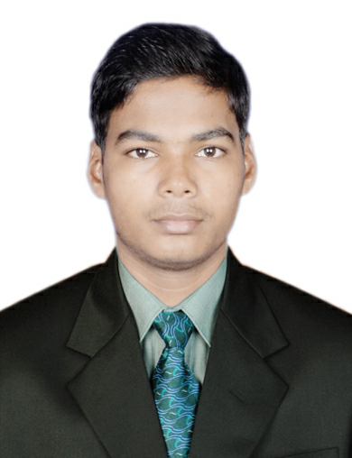
Name : LALITA KRUSHNA SHARMA

Father’s name : DURGA CHARAN NAYAK

Date of Birth : 09th APRIL 1996

Marital status : Single

Gender : Male

Nationality : Indian

Address : MARKANDESWAR SAHI, PURI

Telephone number : 9439702339, 7008963884 (F)

E-mail ID : lalitakrushnasharma70@gmail.com

Course : Diploma in Mechatronics

College : CTTC (Central Tool Room & Training Centre)

Laguages known : Odia, Hindi, English & Bengali

EDUCATION PROFILE

Course | Institute | Major Subject | Year of Passing | Percentage (%)
10th | Biswambhar  Vidya Pitha,Puri | Oriya, English, Sanskrit, Mathematics, History & Geography, Physical science & Life science | 2011 | 51.50
12th | S.S.B.G  Mahavidyalaya,PURI | Sanskrit, English, Mathematics , Physics, Chemistry, Biology | 2013 | 53.50
 | Diploma  In  Mechatronics | Workshop Technology, Digital, Analog & Industrial Electronics, Electrical Engineering Science, Measuring system, Metrology, Mechatronics system Design, Engg Design(Auto CAD & CREO Parametric 2.0), Microprocessors & Microcontrollers, Control System, C++, Visual Basics, Hydraulics &Pneumatics, PLC & CNC. | 2017 | 75.4(upto 4th  sem)
1 | Academic performance  Rank up to 4th semester | I Sem | II Sem | III Sem | IV Sem | V Sem | VI Sem | Average
1 | Academic performance  Rank up to 4th semester | 62.3% | 70.00% | 83.00% | 86.30% |  |  | 75.04%

ACHIEVEMENTS
- Secured a good Diploma career in our institute with good practical knowledge.

- 2nd position in Robotics Event (Kick Off) program at IIt(Indian Institute Of Technology)

- 3rd position in Robotics Event (Robo Race & Final Destination) at CTTC,Bhubaneswar

PROJECT IN THE ACADEMIC CARRER
- Portable Vice
- Op-Amp Kit
- Three phase induction motor
- Smart Navigation System
- Sky Rim (UAV)

ALSO HAVING KNOWLEDGE ON
- Mechanical: Properties of metal, conventional machining, strength of materials.
- Electronics: Analog, Digital electronics, Analog and digital circuit analysis.
- Electrical: Motors (AC, DC), Generators, Transformers and Alternators
- Microprocessor: 8085, 8086 with Programming.
- Microcontrollers: 8051, PIC 16F87X
- PLC : Ladder language programming and applications on ABB and Siemens.
- Robotics: Designing and programming.
- Pneumatics and hydraulics.
- Computer programming: C, C++ and VB 6.0, CREO PARAMETRIC 2.0, AUTOCAD 2012
- Entrepreneurship development program

DECLARATION
I aspire to see myself as a successful Professional. I can work comfortably and efficiently in team and in any environment. I, hereby, certify that the above-mentioned information is true to the best of my knowledge and belief.

Date: Signature of Candidate
Place: Bhubaneswar

